EDXL Resource Messaging
Standard Requirements Supplement
to the draft EDXL Standard Format for Resource Messaging Package
- Submitted to the OASIS Emergency Management Technical Committee

The Disaster Management EDXL Project Team

Document Metadata

Document Distribution List
(Optional per the EM-TC)
Name | Distributed  (Yes / No) | Date  (mm/dd/yy)

Modification History
(Please refer to the “EDXL Standard Format for Resource Messaging” document – draft – Version 3.1 dated August 12, 2005)
Version  No. | Date  <mm/dd/yy> | Changes made | Author | Reviewers | Documents Affected

Approvals
(Optional per the EM-TC)
Role | Organization | Authorized Person | Response | Date

Table of Contents

0. Document Metadata 2
Document Distribution List 2
Modification History 2
Approvals 2
Table of Contents 3
1. Introduction 4
Document Scope and Purpose 4
Background Information 4
History 5
Acronyms and Definitions 5
Reference Documents 5
Assumptions 5
2. Standards Overview 5
Standards Scope 5
“Not Addressed At This Time” 7
Architectural and Open System Interaction Requirements 7
Standards Compatibility 7
Activity Diagram 8
Data Dictionary 11
Constraints and Assumptions 12
3. Focus for Requirements 12
End User Information 12
Entity Information (existing systems) 13
Critical to Quality 13
4. Usability Focus 13
Actor Profile 13
Business Use Cases 13
Usage Scenarios 14
5. Functional Requirements 14
General Requirements 14
Domain Specific Requirements 28
Condition Specific Requirements 39
Quality Requirements 40
Portability/Compatibility Requirements 41
Security Requirements 41
Maintainability Requirements 41
Availability, Reliability Requirements 41
etc… 41
etc… 41
Testability Requirements 41
Usability Requirements 41
Usability Measurements 42
Documentation Requirements 42
Fault Tolerance 42
Diagnosis and Monitoring 42

Introduction

Document Scope and Purpose
This supplemental document specifies the requirements supporting the “EDXL Standard Format for Resource Messaging” package submitted to OASIS on August 29, 2005 (see “Background Information” below). This document in the format provided was requested by the OASIS Emergency Management Technical Committee (EM-TC) and is provided by the EDXL Project Team. This document scope is identical to that specified in the original package submitted to OASIS, but specifies requirements supporting that package.

Background Information
On August 29, 2005 the “EDXL Standard Format for Resource Messaging” package was submitted to OASIS by Matt Walton on behalf of the Emergency Interoperability Consortium (EIC), with the concurrence of the Department of Homeland Security's Disaster Management e-Gov Initiative and the Standards Working Group it has sponsored. This package included the following documents submitted for standards review and formalization by the Emergency Management Technical Committee (EM-TC) under the OASIS process.

- EDXL Standard Format for Resource Messaging document – draft – Version 3.1 dated August 12, 2005
- EDXL Standard Format for Resource Messaging –draft XML Schema
- “Proposed EDXL Message List" – Jon Skeels (USDA Forest Service and ROSS)
On September 12, 2005 the package was accepted by Elysa Jones, Chair of the OASIS EM-TC (OASIS EM-TC voted on 9/6/05). The EM-TC determined that this effort falls within their charter, and the effort was accepted as a work product for the committee.

On September 13, 2005 the EDXL Resource Message Use Examples were submitted to the OASIS EM-TC under separate cover, and were posted to the OASIS EM-TC web site.
- Safecom Explosion
- California Cedar Fire of 2003
- Hurricane
- Influenza

On September 27, 2005, the OASIS EM-TC provided this requirements document template to the EDXL Project Team requesting a supplemental document be provided specifying the requirements supporting the original Resource Messaging package.

History
For background and overview information, please refer to the “EDXL Standard Format for Resource Messaging” document – draft – Version 3.1 dated August 12, 2005

Acronyms and Definitions
(Please refer to the “EDXL Standard Format for Resource Messaging” document – draft – Version 3.1 dated August 12, 2005)
Acronyms / Definitions / Terms | Description

Reference Documents
Document Title | Version No.
Cover Letter – “Messages for Standardization - EDXL Standard Format for Resource Messaging” from Matt Walton (chair, EIC) to Elysa Jones (chair, OASIS EM-TC) | August 29, 2005
EDXL Standard Format for Resource Messaging | Version 3.1 August 12. 2005
EDXL Standard Format for Resource Messaging –draft XML Schema | August 12, 2005
“Proposed EDXL Message List" – Jon Skeels (USDA Forest Service and the ROSS) | August 12, 2005
EDXL Resource Messaging Use Examples (Safecom Explosion, California Cedar Fire of 2003, Hurricane, Influenza) | August 12, 2005

Assumptions
See “Standards Overview”.

Standards Overview

Standards Scope
This supplemental document specifies the requirements supporting the “EDXL Standard Format for Resource Messaging” package submitted to OASIS on August 29, 2005 (see “Background Information” above). As stated in the submission, that proposal provides an initial set of fourteen resource messages for standardization covering the full scope of EDXL Resource Messaging. Included with this proposal is a list of messages submitted by Jon Skeels representing the USDA Forest Service and the ROSS system. Although it is believed that most of this list is represented in the core documentation, this document is submitted for additional consideration by the EM-TC, and may result in definition of additional resource messages. Taken together, these messages provide a foundation for integrated EDXL Resource communication to permit rapid and efficient data sharing among data systems used for incident and event management by all emergency response professions.

The scope of these standards includes:
- Requirements are presented in the context of EDXL, and are to be focused primarily on developing specific functional message standards (one or more XML-based messaging standards).
- The outcome of the EDXL Resource Messaging effort is a package of requirements and detailed specification agreed upon by Emergency Response practitioners, Standards Working Group, DHS DM, and EIC, which will be submitted to become a set of public standards that governs event, incident and emergency response resource messaging (information sharing).
- NIMS / ICS adheres to NIMS guidelines – Within the scope of this effort, RM standards must support NIMS information needs contained in the NIMS document, Chapter IV – Resource Management
- National focus - Resource Messaging (RM) standards must support local, tribal, state, federal and non-governmental agencies, stakeholders, and systems providers’ rapid information sharing about resources.
- Broad functions supported - RM standards must support event, incident and emergency management functions. This includes everyday as well as broad-scale planned and unplanned events, incidents and emergencies.
- Resource Management – RM standards must support resource management, defined as “any action to identify sources and obtain resources needed to support event, incident and emergency response activities; coordinate the supply, allocation, distribution, and delivery of resources so that they arrive where and when most needed; and maintain accountability for the resources used”.
- Resource definition – For purposes of RM standards, resources may refer to persons and things required in events, incidents and emergencies such as human resources, vehicles, equipment, supplies, and facilities, as well as packages / teams composed of many of these.
- Incident Management Stages – RM standards must support processes of finding, requesting and getting resources to an incident or event, demobilization and return from the incident or event, tracking resource time-line and providing status of all types of resources. In terms of incident life-cycle stages, RM standards must support:
  - Resource preparedness activities
  - Pre-staging of resource for events or in preparation for an incident or emergency
  - Resource Management processes during initial and ongoing response (Resource messages will be used by actors within and during an incident or event to request resources etc.).
  - Demobilization/release of resources from an event or incident

“Not Addressed At This Time”

- At-Incident Management - As stated above, RM must support Resource Management processes (finding, requesting, and getting resources to and from an incident or event) during initial and ongoing response. The practitioner community has no requirement for messaging to support 'At-incident' Resource Management, feeling that messaging application may actually hinder response efforts without adding value. Per their direction, requirements analysis was not performed to address the additional processes and information needs of 'At-Incident Management' for resource.
- Financial management – Aside from communicating a resource price quote, processes concerned with resource cost tracking and reimbursement is not addressed within the scope of these requirements.
- Resource Content - This specification primarily addresses EDXL Emergency Management Resource message structure (core message elements). Message Content (data model or dictionary describing resources) is out of scope and will be defined by a supporting process.
- Incident Notification - Identification, definition, and notification of an incident or event are processes / procedural issues outside of this Resource Messaging requirements scope.
- Donations / donations management is outside of Resource Messaging requirements scope.
- Requesting an “Action” is outside of Resource Messaging requirements scope, and is considered to be an incident operations requirement. Example: “Request evacuation of nearby school” is a request for an action rather than for a resource which specifies the need and provides authority but is managed by “outside” resources.

Architectural and Open System Interaction Requirements
(Optional per the EM-TC)
Hardware:
Software:
Communications:

Standards Compatibility

Note: “Compatibility” in this context means that formats are compatible or can be referenced, e.g. ROSS messages—optional external languages.
Standard will be compatible with the following existing standards, policies or practices:
- The EDXL family of standards, in particular the Distribution Element
- NIMS – National Incident Management System
- ICS – Incident Command System
- GJXDM – Global Justice XML Data Model / dictionary
- NIEM – National Information Exchange Model
- ARMS – Automated Resource Management System
- IEEE 1512 – Transportation Emergency Data Standards
- ROSS – Resource Ordering and Status System (URL to come)

Activity Diagram
The Activity Diagrams are derived from the Use Examples provided to the OASIS Emergency Management Technical Committee. The basic purpose of these activity diagrams is to provide a perspective on the process and the interactions, and is not all encompassing (e.g. “Return Resource” messages are not covered here).
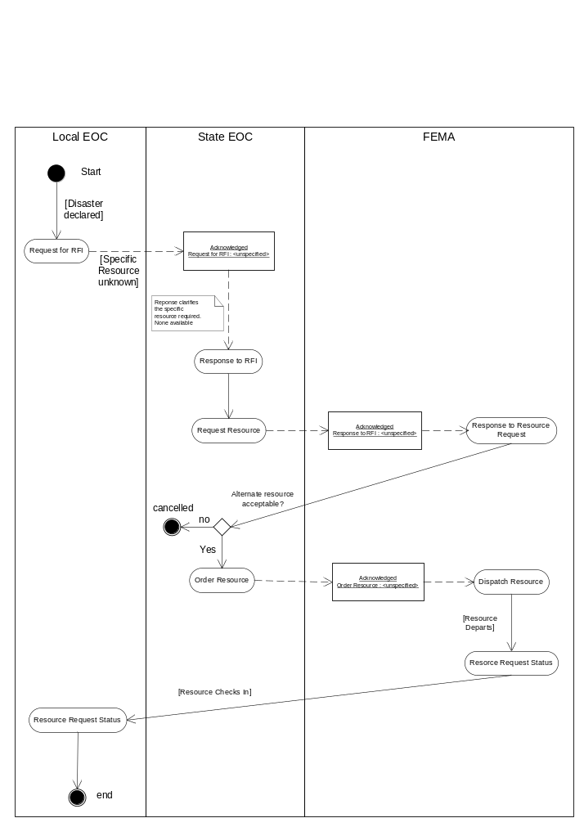

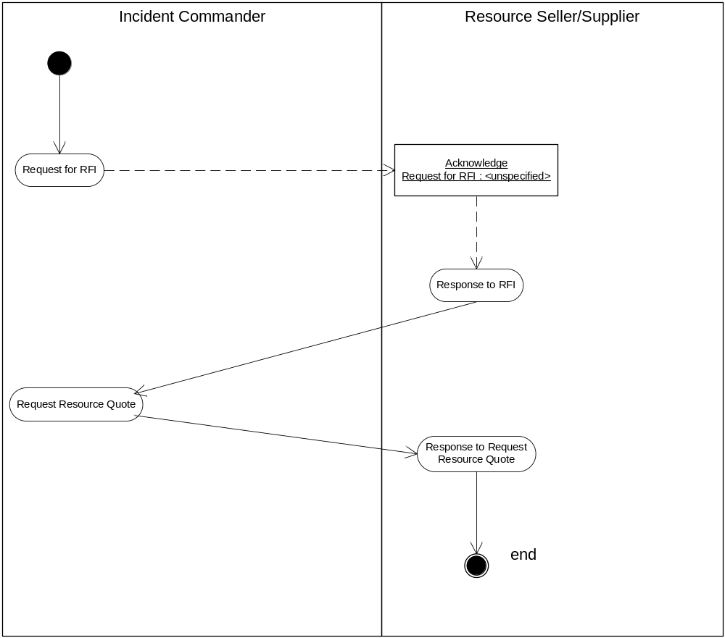

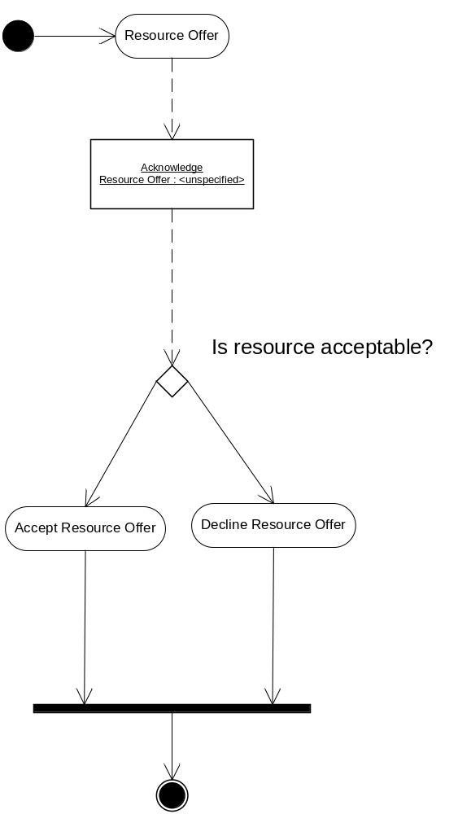

Data Dictionary
For the specific list of required Resource Message information elements, please refer to the “EDXL Standard Format for Resource Messaging” document – draft – Version 3.1 dated August 12, 2005 - Tables 2, 3, 4 and 5. These tables contain the information elements that must be included within resource messages, providing definitions, examples and references. Although different semantics may be considered, these elements (or elements meeting the defined intent) are required by the practitioners and Standards Working Group. Many of these elements are specified by NIMS, while others were provided from other key efforts or systems in this space such as ROSS.

Term | Definition

Constraints and Assumptions
See “Standards Overview”.

Focus for Requirements

End User Information
User | Base Needs
Emergency Management | - Request for information  - Response to request for information  - Request persons or things  - Response to request for persons or things  - Requisition Resource  - Request for quotes  - Response to request for quotes  - Request and report status of resources  - Response to request for status of resources and request for report  - Return resource  - Provide unsolicited offers
Dispatch | - Request for information  - Response to request for information  - Dispatch resources  - Provide status on resources  - Return resource
Supporting Jurisdiction | - Request for information  - Response to request for information  - Request for quotes  - Response to request for quotes  - Provide unsolicited offers  - Provider status of resources  - Request for return resource  - Response to request for return resource
Resources Supplier/Seller | - Request for information  - Response to request for information  - Request for quotes  - Response to request for quotes  - Provide unsolicited offers  - Dispatch resources  - Report status of resources  - Return Resource

Entity Information (existing systems)
(Optional per the EM-TC)
Entity | Specification

Critical to Quality
(Optional per the EM-TC)

Usability Focus

Actor Profile
NOTE: This list is not exhaustive. It is provided only as an example.
Actor | Role and Description
Emergency Manager - State, Local and Federal – various branches
Emergency Operations Center (EOC)
Incident Commander
Dispatch Manager (various branches)
LE Branch (LE)
Fire Branch (Fire)
Logistics Manager
Health Branch
Transportation Branch
EMS Branch
Mobile Command (MC)
Public Works and Utility
Resource Management System
Inventory System
Dispatch System
Transportation Management Center System
Hospital
Political Entities / Government Offices (Governor, Mayor…)

Business Use Cases
(Optional for this Resource Messaging document per the EM-TC)

Usage Scenarios
On September 13, 2005 the following EDXL Resource Message Use Examples were submitted to the OASIS EM-TC under separate cover, and were posted to the OASIS EM-TC web site. The original written real-world scenarios used to generate these Use Examples may also be provided upon request.
- Safecom Explosion
- California Cedar Fire of 2003
- Hurricane
- Influenza

Functional Requirements

General Requirements
Resource Messaging must provide the following functional messaging capabilities in context of overall scope and requirements stated herein.
Within each table:
- “SWG” refers to the EDXL practitioners and Standards Working Group sponsored by the Department of Homeland Security's Disaster Management e-Gov Initiative as part of the public private partnership effort with the EIC.
- “RM” refers to “Resource Messaging”
(Within each table, all information following “Requirement Description” is optional per the EM-TC).

No |  | Keyword | [EDXL-DM] | Date | [10-19-2005] | Source | [SWG]
Priority (Essential / Useful / Desirable) |  |  | [Essential] | Stability (Unlikely to change / May change / Most likely to change) | [Unlikely to change] | Release # | [0.1]
Requirement Description:
[The EDXL-RM is dependent on EDXL-DM.]
Field | Mandatory | Field Size (Characters) | Remarks

Rationale:
Verification criteria:
Assumptions:
Constraints:

No |  | Keyword | [Process] | Date | [08/12/2005] | Source | [SWG]
Priority (Essential / Useful / Desirable) |  |  | [Essential] | Stability (Unlikely to change / May change / Most likely to change) | [Unlikely to change] | Release # | [0.1]
Requirement Description:
[General: RM standards must support processes of finding, requesting and getting resources to an incident or event, demobilization and return from the incident or event, tracking resource time-line and status of all types of resources.]
Field | Mandatory | Field Size (Characters) | Remarks

Rationale:
Verification criteria:
Assumptions:
Constraints:

No |  | Keyword | [Request] | Date | [08/12/2005] | Source | [SWG]
Priority (Essential / Useful / Desirable) |  |  | [Essential] | Stability (Unlikely to change / May change / Most likely to change) | [Unlikely to change] | Release # | [0.1]
Requirement Description:
[Request Resource – Provide the ability to request resources and to provide responses to resource requests.
- Multiple responses may be provided.
- Each response must have the ability for the sender to list one or more resource(s) or resource options which they feel represent a suitable reply to the previous requesting message. These may not match one to one unless the requested resources are able to be offered.]
Field | Mandatory | Field Size (Characters) | Remarks

Rationale:
Verification criteria:
Assumptions:
Constraints:

No |  | Keyword | [Order] | Date | [08/12/2005] | Source | [SWG]
Priority (Essential / Useful / Desirable) |  |  | [Essential] | Stability (Unlikely to change / May change / Most likely to change) | [Unlikely to change] | Release # | [0.1]
Requirement Description:
[Requisition Resource – Provide the ability to order specific resource or to confirm the specific resource or requirement that should be provided to meet the original request for resource. This “requisition confirmation” is required to specify which resource from all available options or responses should actually be provided to meet the need. This is needed when many subsequent messages (responses) result from an original Request Resource, or when multiple resource/resource options are specified in a single response. The Resource Requisition message confirms which resource should actually be provided to meet the need. It must be agnostic to organization-specific business processes or accounting systems, although it may reference such a process or system.]
Field | Mandatory | Field Size (Characters) | Remarks

Rationale:
Verification criteria:
Assumptions:
Constraints:

No |  | Keyword | [Commit] | Date | [08/12/2005] | Source | [SWG]
Priority (Essential / Useful / Desirable) |  |  | [Essential] | Stability (Unlikely to change / May change / Most likely to change) | [Unlikely to change] | Release # | [0.1]
Requirement Description:
[Commit Resource – Provide the ability for the “supplying” organization or entity to commit all or part of a specific resource to a Response to Resource Request or Resource Requisition. ]
Field | Mandatory | Field Size (Characters) | Remarks

Rationale:
Verification criteria:
Assumptions:
Constraints:

No |  | Keyword | [Decline] | Date | [08/12/2005] | Source | [SWG]
Priority (Essential / Useful / Desirable) |  |  | [Essential] | Stability (Unlikely to change / May change / Most likely to change) | [Unlikely to change] | Release # | [0.1]
Requirement Description:
[Decline Responses – Provide the ability for the recipient of responses to decline responses to resource requests received and provide notification of same. This is required to facilitate response in a situation where several responses to a resource request or other resource message are received.]
Field | Mandatory | Field Size (Characters) | Remarks

Rationale:
Verification criteria:
Assumptions:
Constraints:

No |  | Keyword | [Info] | Date | [08/12/2005] | Source | [SWG]
Priority (Essential / Useful / Desirable) |  |  | [Essential] | Stability (Unlikely to change / May change / Most likely to change) | [Unlikely to change] | Release # | [0.1]
Requirement Description:
[Request Information - Provide the ability to request information and provide responses to those requests.
  - Provide the ability to request information, ask questions, provide description of situation / general resource requirement information (general description of situation and resources needs) to a recipient, regardless of whether the sender / recipient has authority to request resources.
  - Provide the ability to provide responses to requests for information; providing general description, feedback or listing of resources that may meet the specified need or criteria; or an explicit “no response”. Responders should be given the option to select from a list or enter a free-text response.]
Field | Mandatory | Field Size (Characters) | Remarks

Rationale:
Verification criteria:
Assumptions:
Constraints:

No |  | Keyword | [Offer] | Date | [08/12/2005] | Source | [SWG]
Priority (Essential / Useful / Desirable) |  |  | [Essential] | Stability (Unlikely to change / May change / Most likely to change) | [Unlikely to change] | Release # | [0.1]
Requirement Description:
[Offer Unsolicited Resources – Provide the ability to offer available resources (that have not been requested) to assist with an emergency response, and to respond to those offers (e.g. acknowledge requisition, or decline). ]
Field | Mandatory | Field Size (Characters) | Remarks

Rationale:
Verification criteria:
Assumptions:
Constraints:

No |  | Keyword | [Release] | Date | [08/12/2005] | Source | [SWG]
Priority (Essential / Useful / Desirable) |  |  | [Essential] | Stability (Unlikely to change / May change / Most likely to change) | [Unlikely to change] | Release # | [0.1]
Requirement Description:
[Release Resource (demobilize) – Provide the ability to request and/or communicate release of resource from incident assignment, and to provide responses.
- Provided the ability for incident authorities to release a resource back to its original point of assignment or to another location / assignment, and provide notification (incident may be ongoing or complete).
- Provide the ability for a supplying organization or entity to request return (demobilization) to bring a resource back to its original point of assignment or to another location / assignment. The incident may be ongoing or complete ("I want my stuff back").
- Provide the ability to provide responses indicating whether or not the resource may be released, with relevant time-line information.]
Field | Mandatory | Field Size (Characters) | Remarks

Rationale:
Verification criteria:
Assumptions:
Constraints:

No |  | Keyword | [Quote] | Date | [08/12/2005] | Source | [SWG]
Priority (Essential / Useful / Desirable) |  |  | [Essential] | Stability (Unlikely to change / May change / Most likely to change) | [Unlikely to change] | Release # | [0.1]
Requirement Description:
[Request Quote – Provide the ability to request resource price quote from a seller or supplier, and to provide responses.
- Responses must allow the sender to list a set of resources which they feel represents a suitable reply to the previous requesting message with pricing information. These will not match one to one unless the requested resources are available to be offered. ]
Field | Mandatory | Field Size (Characters) | Remarks

Rationale:
Verification criteria:
Assumptions:
Constraints:

No |  | Keyword | [Disposition] | Date | [08/12/2005] | Source | [SWG]
Priority (Essential / Useful / Desirable) |  |  | [Essential] | Stability (Unlikely to change / May change / Most likely to change) | [Unlikely to change] | Release # | [0.1]
Requirement Description:
[Request Resource Disposition – Provide the ability to request the current disposition (per NIMS definition) of resource in relation to a previous Resource Requisition, Release Resource, or Request to Return Resource.]
Field | Mandatory | Field Size (Characters) | Remarks

Rationale:
Verification criteria:
Assumptions:
Constraints:

No |  | Keyword | [Disposition] | Date | [08/12/2005] | Source | [SWG]
Priority (Essential / Useful / Desirable) |  |  | [Essential] | Stability (Unlikely to change / May change / Most likely to change) | [Unlikely to change] | Release # | [0.1]
Requirement Description:
[Provide Request Disposition – Provide the ability to report on the current disposition (per NIMS definition) of any Resource Request message, providing all available resource elements including resource "tracking/time-line" information for accountability such as "Date Committed" or "Estimated Date / Time Of Arrival". May be provided proactively (without solicitation), or in response to a Request for Resource Disposition.]
Field | Mandatory | Field Size (Characters) | Remarks

Rationale:
Verification criteria:
Assumptions:
Constraints:

No |  | Keyword | [Ack] | Date | [08/12/2005] | Source | [SWG]
Priority (Essential / Useful / Desirable) |  |  | [Essential] | Stability (Unlikely to change / May change / Most likely to change) | [Unlikely to change] | Release # | [0.1]
Requirement Description:
[Provide the ability to acknowledge any specific EDXL-RM message that was received. ]
Field | Mandatory | Field Size (Characters) | Remarks

Rationale:
Verification criteria:
Assumptions:
Constraints:

No |  | Keyword | [Update] | Date | [08/12/2005] | Source | [SWG]
Priority (Essential / Useful / Desirable) |  |  | [Essential] | Stability (Unlikely to change / May change / Most likely to change) | [Unlikely to change] | Release # | [0.1]
Requirement Description:
[Provide the ability to update (revise) any resource message. This capability is required to address the situation where the message sender needs to change one or more elements of information due to their error, or because new or additional information has been provided. When a message is updated, the intent is to send the entire message again with the revised information. Only the orginal sender (as defined in EDXL-DE) may update a message.]
Field | Mandatory | Field Size (Characters) | Remarks

Rationale:
Verification criteria:
Assumptions:
Constraints:

No |  | Keyword | [Cancel] | Date | [08/12/2005] | Source | [SWG]
Priority (Essential / Useful / Desirable) |  |  | [Essential] | Stability (Unlikely to change / May change / Most likely to change) | [Unlikely to change] | Release # | [0.1]
Requirement Description:
[Provide the ability to cancel any resource message. (If a cancellation needs to be retracted, the sender must send a new message reiterating the original message with or without additional content.)]
Field | Mandatory | Field Size (Characters) | Remarks

Rationale:
Verification criteria:
Assumptions:
Constraints:

No |  | Keyword | [Multiple resource] | Date | [08/12/2005] | Source | [SWG]
Priority (Essential / Useful / Desirable) |  |  | [Essential] | Stability (Unlikely to change / May change / Most likely to change) | [Unlikely to change] | Release # | [0.1]
Requirement Description:
[Response to Resource Requests - Response to Resource Request messages must allow recipient to list resources which represent a suitable reply to the Resource Request (i.e. Resource Response might or might not directly match original Request). Recipient must have the ability for the message to contain multiple specific resources that could fill the need.]
Field | Mandatory | Field Size (Characters) | Remarks

Rationale:
Verification criteria:
Assumptions:
Constraints:

No |  | Keyword | [Advise] | Date | [08/12/2005] | Source | [SWG]
Priority (Essential / Useful / Desirable) |  |  | [Essential] | Stability (Unlikely to change / May change / Most likely to change) | [Unlikely to change] | Release # | [0.1]
Requirement Description:
[Notify Auxiliary Recipients – Provide the ability to advise or notify any auxiliary recipient (like a government official) about any resource message as an "FYI", where the auxiliary recipient was not included on original distribution. The purpose is to keep others informed of Resource communications and to minimize Resource Response duplication (synonymous with email “CC:” or “Forward”). This message must have its own ID. ]
Field | Mandatory | Field Size (Characters) | Remarks

Rationale:
Verification criteria:
Assumptions:
Constraints:

Domain Specific Requirements
Resource Messaging must address the following messaging information needs in context of overall scope and requirements stated herein. This section provides general reference to the information elements required for resource messages. For the specific list of required Resource Message information elements, please refer to the “EDXL Standard Format for Resource Messaging” document – draft – Version 3.1 dated August 12, 2005 - Tables 2, 3, 4 and 5. Although different semantics may be considered, these elements (or elements meeting the defined intent) are required by the practitioners and Standards Working Group.

Within each table:
- “SWG” refers to the EDXL practitioners and Standards Working Group sponsored by the Department of Homeland Security's Disaster Management e-Gov Initiative as part of the public private partnership effort with the EIC.
- “RM” refers to “Resource Messaging”

(Within each table, all information following “Requirement Description” is optional per the EM-TC)

No |  | Keyword | [NIMS] | Date | [08/12/2005] | Source | [SWG]
Priority (Essential / Useful / Desirable) |  |  | [Essential] | Stability (Unlikely to change / May change / Most likely to change) | [Unlikely to change] | Release # | [0.1]
Requirement Description:
[NIMS / ICS Compliance – Within the scope of this effort, RM standards must support NIMS information needs contained in the NIMS document, Chapter IV – Resource Management]
Field | Mandatory | Field Size (Characters) | Remarks

Rationale:
Verification criteria:
Assumptions:
Constraints:

No |  | Keyword | [Incident] | Date | [08/12/2005] | Source | [SWG]
Priority (Essential / Useful / Desirable) |  |  | [Essential] | Stability (Unlikely to change / May change / Most likely to change) | [Unlikely to change] | Release # | [0.1]
Requirement Description:
[RM must provide message elements that refer to incidents and events. Resource messages do not need to contain descriptive information about the incident or event. Incident and event references are optional fields because EDXL messaging may be applied outside the scope of an actual incident or event. For example, EDXL Resource Messages may be used to support preparedness activities, pre-staging of resource, or training]
Field | Mandatory | Field Size (Characters) | Remarks

Rationale:
Verification criteria:
Assumptions:
Constraints:

No |  | Keyword | [ID] | Date | [08/12/2005] | Source | [SWG]
Priority (Essential / Useful / Desirable) |  |  | [Essential] | Stability (Unlikely to change / May change / Most likely to change) | [Unlikely to change] | Release # | [0.1]
Requirement Description:
[Provide information to uniquely identify each resource message. The identifier must include an ID or number.]
Field | Mandatory | Field Size (Characters) | Remarks

Rationale:
Verification criteria:
Assumptions:
Constraints:

No |  | Keyword | [ID] | Date | [08/12/2005] | Source | [SWG]
Priority (Essential / Useful / Desirable) |  |  | [Essential] | Stability (Unlikely to change / May change / Most likely to change) | [Unlikely to change] | Release # | [0.1]
Requirement Description:
[Provide date/time within each message.]
Field | Mandatory | Field Size (Characters) | Remarks

Rationale:
Verification criteria:
Assumptions:
Constraints:

No |  | Keyword | [Status] | Date | [08/12/2005] | Source | [SWG]
Priority (Essential / Useful / Desirable) |  |  | [Essential] | Stability (Unlikely to change / May change / Most likely to change) | [Unlikely to change] | Release # | [0.1]
Requirement Description:
[RM must provide the current msgStatus of a resource message such as “acknowledged” or “in-progress”]
Field | Mandatory | Field Size (Characters) | Remarks

Rationale:
Verification criteria:
Assumptions:
Constraints:

No |  | Keyword | [contacts] | Date | [08/12/2005] | Source | [SWG]
Priority (Essential / Useful / Desirable) |  |  | [Essential] | Stability (Unlikely to change / May change / Most likely to change) | [Unlikely to change] | Release # | [0.1]
Requirement Description:
[RM must provide contact information for actors associated with the message. At a minimum, contacts must include role, requestor or sender, subject matter expert, and organization or entity responding. At a minimum, contact information associated with these roles must include phone numbers, email, and radio frequency.]
Field | Mandatory | Field Size (Characters) | Remarks

Rationale:
Verification criteria:
Assumptions:
Constraints: Roles must be included

No |  | Keyword | [approval] | Date | [08/12/2005] | Source | [SWG]
Priority (Essential / Useful / Desirable) |  |  | [Essential] | Stability (Unlikely to change / May change / Most likely to change) | [Unlikely to change] | Release # | [0.1]
Requirement Description:
[RM must provide optional information indicating message (request) approval with funding information (e.g. fund code) if applicable.]
Field | Mandatory | Field Size (Characters) | Remarks

Rationale:
Verification criteria:
Assumptions:
Constraints:

No |  | Keyword | [resource selection] | Date | [08/12/2005] | Source | [SWG]
Priority (Essential / Useful / Desirable) |  |  | [Essential] | Stability (Unlikely to change / May change / Most likely to change) | [Unlikely to change] | Release # | [0.1]
Requirement Description:
[RM design must provide the ability to reference external tables or lists for specifying resource content.
- Resource Content – These requirements primarily address EDXL Emergency Management Resource message structure (core message elements). Message Content (data model or dictionary describing resources) is out of scope and will be defined by a supporting process.
- Selection of resource content - RM must provide the capability to leverage other efforts involved in resource definition and typing by providing reference to tables or lists that define or type resource content, and allowing selection of resource.]
Field | Mandatory | Field Size (Characters) | Remarks

Rationale:
Verification criteria:
Assumptions:
Constraints:

No |  | Keyword | [specify resource] | Date | [08/12/2005] | Source | [SWG]
Priority (Essential / Useful / Desirable) |  |  | [Essential] | Stability (Unlikely to change / May change / Most likely to change) | [Unlikely to change] | Release # | [0.1]
Requirement Description:
[RM must provide resource information with quantities and current disposition for any type or kind of resource that may be required in preparation for or in response to planned events and unplanned incidents, emergencies and disasters. The capability is required to specify resource in a number of flexible ways:
- RM must provide for the representation of different types of resources.
- Specifically specify Resource – RM must provide the ability to request or refer to specific resource.
- Generally specify Resource – RM must provide the ability to provide a general description of resource, in lieu of or in addition to selection of resource from other lists. Additionally, this description must be free-form, allowing (for example) general description of the situation requiring resource, resource characteristics, requirements or capabilities, resource types or general needs, or may simply state the broad mission to be addressed and support requirements of the resource. ]
Field | Mandatory | Field Size (Characters) | Remarks

Rationale:
Verification criteria:
Assumptions:
Constraints:

No |  | Keyword | [special requirement] | Date | [08/12/2005] | Source | [SWG]
Priority (Essential / Useful / Desirable) |  |  | [Essential] | Stability (Unlikely to change / May change / Most likely to change) | [Unlikely to change] | Release # | [0.1]
Requirement Description:
[RM must provide information specifying any special requirement for the requested resource (such as protective equipment or qualified personnel) beyond normal requirements associated with that resource.]
Field | Mandatory | Field Size (Characters) | Remarks

Rationale:
Verification criteria:
Assumptions:
Constraints:

No |  | Keyword | [request resource] | Date | [08/12/2005] | Source | [SWG]
Priority (Essential / Useful / Desirable) |  |  | [Essential] | Stability (Unlikely to change / May change / Most likely to change) | [Unlikely to change] | Release # | [0.1]
Requirement Description:
[RM must provide descriptive information required to request or process a resource request including actual and anticipated / estimated information. Note that many of these elements are specified by NIMS, while others were provided from other key efforts or systems in this space such as ROSS.
- Requested location (specific location, such as area or address)
- Report-to location (where resource should check in, if different from requested location)
- Requested arrival date/time
- Anticipated resource assignment
- Anticipated return date
- Navigation instructions
- Description of condition(s) governing the availability of resources [reference which use case??]]
Field | Mandatory | Field Size (Characters) | Remarks

Rationale:
Verification criteria:
Assumptions:
Constraints:

No |  | Keyword | [accept / decline] | Date | [08/12/2005] | Source | [SWG]
Priority (Essential / Useful / Desirable) |  |  | [Essential] | Stability (Unlikely to change / May change / Most likely to change) | [Unlikely to change] | Release # | [0.1]
Requirement Description:
[RM must provide information indicating accept or decline of a resource request, response, offer, etc. with explanatory text.]
Field | Mandatory | Field Size (Characters) | Remarks

Rationale:
Verification criteria:
Assumptions:
Constraints:
No |  | Keyword | [respond / track resource] | Date | [08/12/2005] | Source | [SWG]
Priority (Essential / Useful / Desirable) |  |  | [Essential] | Stability (Unlikely to change / May change / Most likely to change) | [Unlikely to change] | Release # | [0.1]
Requirement Description:
[RM must provide descriptive information required to respond to requests, process a resource and account for resource associated with requisitioned resources including actual and anticipated / estimated information. The term “accountability” in NIMS refers to resource status and tracking to ensure all resources are “accounted for”. This information allows basic “time-line” tracking (actual and estimated) of requested resources. Note that many of these elements are specified by NIMS, while others were provided from other key efforts or systems in this space such as ROSS. The following are examples of descriptive information that RM must support. [This requirement may be revised following consultation with practioners.]
  - Current location
- Resource price quote
  - Available date
- Reporting name and instructions
  - Order number
  - Committed date
  - Place of departure
  - Mode of transportation
  - Estimated and actual departure and arrival date / time]
Field | Mandatory | Field Size (Characters) | Remarks

Rationale:
Verification criteria:
Assumptions:
Constraints:

No |  | Keyword | [location] | Date | [08/12/2005] | Source | [SWG]
Priority (Essential / Useful / Desirable) |  |  | [Essential] | Stability (Unlikely to change / May change / Most likely to change) | [Unlikely to change] | Release # | [0.1]
Requirement Description:
[Specify Location Information – RM messaging must provide flexible options to specify resource location anywhere in the country. These must include methods for specifying:
- Mailing addresses
- Geographic coordinates
- Spatial coordinates
- Map locations
- Relative locations
- Altitude / depth
- Time stamp with location

These may include:
- Other location elements facilitating flexible location specification
- Source of location report]
Field | Mandatory | Field Size (Characters) | Remarks

Rationale:
Verification criteria:
Assumptions:
Constraints:

Condition Specific Requirements
(None provided)
No |  | Keyword | [key] | Date | [00/00/0000] | Source | [person/org]
Priority (Essential / Useful / Desirable) |  |  | [Essential] | Stability (Unlikely to change / May change / Most likely to change) | [May change] | Release # | [0.1]
Requirement Description:
[text]
Field | Mandatory | Field Size (Characters) | Remarks

Rationale:
Verification criteria:
Assumptions:
Constraints:

Quality Requirements
(None provided)
No |  | Keyword | [key] | Date | [00/00/0000] | Source | [person/org]
Priority (Essential / Useful / Desirable) |  |  | [Essential] | Stability (Unlikely to change / May change / Most likely to change) | [May change] | Release # | [0.1]
Requirement Description:
[text]

Rationale:
Verification criteria:
Assumptions:
Constraints:

-- END OF DOCUMENT --

Portability/Compatibility Requirements
No |  | Keyword | [key] | Date | [00/00/0000] | Source | [person/org]
Priority (Essential / Useful / Desirable) |  |  | [Essential] | Stability (Unlikely to change / May change / Most likely to change) | [May change] | Release # | [0.1]
Requirement Description:
[text]

Rationale:
Verification criteria:
Assumptions:
Constraints:

Security Requirements

Maintainability Requirements

Availability, Reliability Requirements

etc…

etc…

Testability Requirements

Usability Requirements

Usability Measurements

Attribute | Measure
Ease of Learning
Ease of Use
Effectiveness
Satisfaction

Documentation Requirements

Fault Tolerance

Diagnosis and Monitoring

